Supporting Information

Chaoyun Tang,¹⁺ Dipankar Saha,²⁺ Jiacheng Wang,¹ Arvind Chandrasekar,³ Negar Sabouhanian,⁴ Connor L. Witt,² Yulei Wang,¹ Aicheng Chen,⁴ Wei Fan,¹ Chung-Li Dong, ³ Zhu Chen,¹ James J. Watkins,^{2*} and Nianqiang Wu^{1*}

¹ Department of Chemical Engineering, University of Massachusetts, Amherst, MA 01002, United States
²Conte Center for Polymer Research, Department of Polymer Science and Engineering, University of Massachusetts, Amherst, MA 01002, United States
³Department of Physics, Tamkang University, New Taipei City, Taiwan
⁴Department of Chemistry, University of Guelph, Guelph, Canada

*Corresponding author’s email:
nianqiangwu@umass.edu and watkins@umass.edu

+ Equal Contribution

Figure S1. Scheme illustration of thermal pyrolysis instruments and processes.

Figure S2. HAADF-EDX elemental mapping indicates a homogeneous distribution of Mo, carbon, nitrogen, and oxygen atoms throughout the sample. The scale bar for all images is 2 nm.

Figure S3. Scheme illustration of brush polymer template adopted in experiments.

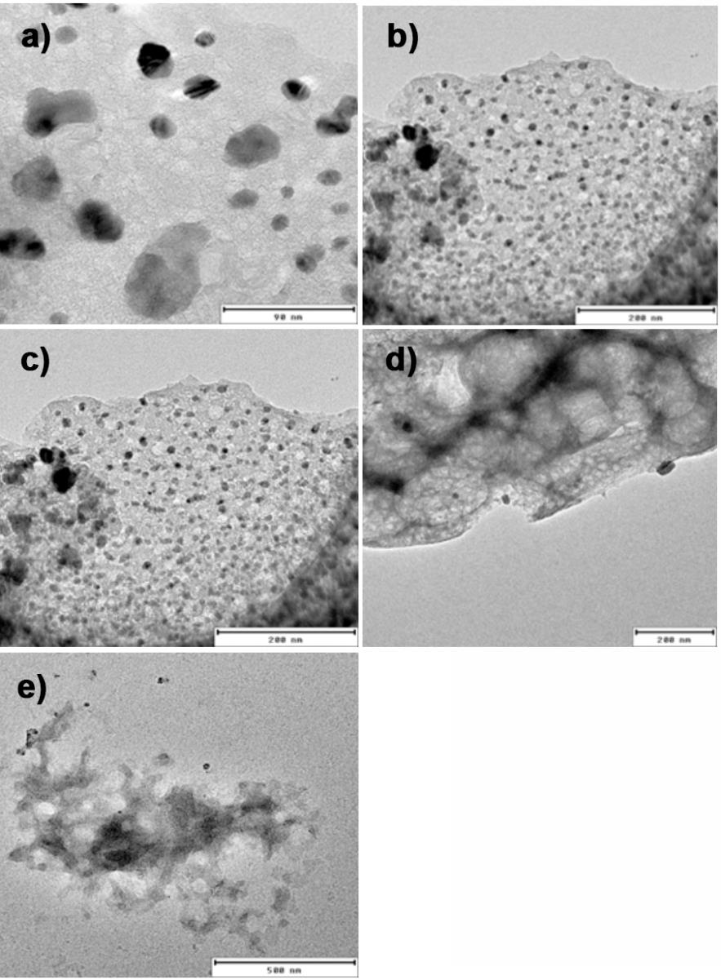
Figure S4. TEM images of as-synthesized samples derived from BBCP with estimated diameters of ) 8 nm, b) 15 nm, c) 21 nm, d) 33 nm, and e) 56 nm.
Figure S5. Statistics pore size distribution of as-synthesized samples derived from BBCP with estimated diameters of a) 8 nm, b) 15 nm, c) 21 nm, d) 33 nm, and e) 56 nm, respectively.
Figure S6. BET absorption/desorption curve of as-synthesized samples with pore size of a) 8 nm, b) 15 nm, c) 21 nm, d) 33 nm, and e) 56 nm.

Figure S7. XRD pattern of as-synthesized Mo/N-C material.

Figure S8. XPS spectra of Mo nanostructure: (a) Mo 3d, (b) O 1s, and (c) N 1s high-resolution spectra showing binding energy peaks for Mo, oxygen, and nitrogen species.
Figure S9. FT EXAFS spectra of 4 and 1 wt. % Mo/C-N, Mo metal powder, MoO₂, MoO₃ and Mo₂C.

Figure S10. Fitting of FT EXAFS spectra of 1 wt. % Mo/C-N.

Sample | Shell Position | N | σ² (Å⁻²) | ∆E₀ (eV) | R (Å) | R-Factor
4 wt. % Mo/C-N | Mo-N | 1.946 | 0.00211 | -7.766 | 1.74896 | 0.0107124
 | Mo-C | 3.892 | 0.00872 | -7.766 | 1.99927
 | Mo-Mo | 5.838 | 0.00991 | -7.766 | 2.97093
1 wt. % Mo/C-N | Mo-N | 1.542 | 0.00062 | -8.019 | 1.75026 | 0.0252494
 | Mo-C | 3.084 | 0.00891 | -8.019 | 1.99616
 | Mo-Mo | 4.626 | 0.00160 | -8.019 | 2.97196
Table S1. Fitting parameters of the Fourier-transformed EXAFS spectrum of Mo.

Figure S11. XPS spectra of as-synthesized 4 wt. % Mo/C-N-21 nanostructure: a) survey spectra and b) high resolution XPS spectra of C 1s.

Figure S12. Linear sweep voltammetry curves of typical 4 wt. % Mo/C-N-21 nanostructure catalyst record in H-type cells in different electrolyte: a) 0.1 M HCl, b) 0.1 M Na₂SO₄ and c) 0.1 M KOH.

Figure S13. Schematic illustration of the gastight electrochemical eNRR system.

Figure S14. Using colorimetric method for detection and quantification of NH₃ in 0.1 M KOH electrolyte after eNRR. a) The UV-Vis absorption spectrum of ${NH}_{4}^{+}$ with different concentrations using indophenol blue method, the characteristic peaks centered at 655 nm correspond to signals of ${NH}_{4}^{+}$. b) The standard curve showing the correlation of ${NH}_{4}^{+}$ concentration with the absorbance peak centered at 655 nm. The error bars represent the standard deviation of over 3 times independent calibrations. c) The UV-Vis absorption spectrum of ${NH}_{4}^{+}$ with different concentrations using Nessler’s reagent method, the characteristic peaks centered at 422 nm correspond to signals of ${NH}_{4}^{+}$. d) The standard curve showing the correlation of ${NH}_{4}^{+}$ concentration with the absorbance peak centered at 422 nm. The error bars represent the standard deviation of over 3 times independent calibrations.
Figure S15. Operando FTIR spectra of 4 wt. % Mo/C-N-21 under N₂ purge at -0.2 V.

Figure S16. a) UV-Vis absorption spectra and b) corresponding calibration curve for the colorimetric N₂H₄ assay in 0.1 M KOH electrolyte.

Figure S17. A comparison of eNRR performance of Reference samples (4 wt. % Mo/C-N-21, loading: 2 mg∙cm⁻²) in different condition: (R) with a potential of -0.2 V vs RHE and N₂ supply. (C1) with a potential of -0.2 V vs RHE and Ar supply. (C2) using blank GDE with a potential of -0.2 V vs RHE and N₂ supply. (C3) with a open circle potential and N₂ supply.

Figure S18. Quantifying the ammonia production of 4 wt. % Mo/C-N-21 operated in a flow cell for 10 hours by NMR with ¹⁵N labelling.

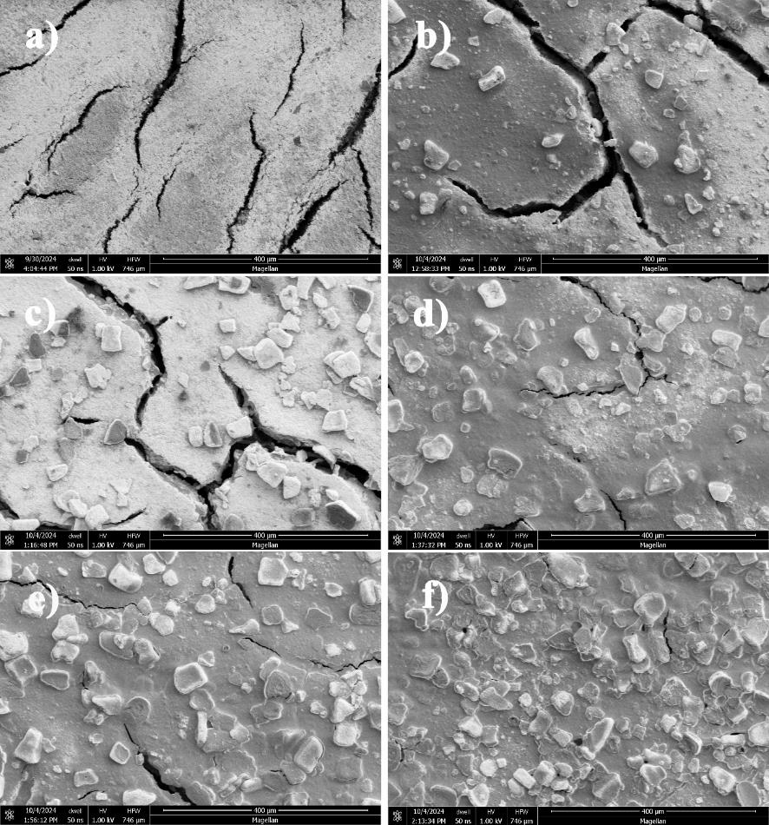
Figure S19. SEM images of as-fabricated GDE with different catalyst loading: a) Blank GDL, b) 0.5 mg∙cm⁻², c) 1 mg∙cm⁻², d) 1.5 mg∙cm⁻², e) 2 mg∙cm⁻², f) 2.5 mg∙cm⁻².

Figure S20. Faradaic efficiencies and NH₃ yield rate of 4 wt. % Mo-PNC-21 in GDE with different catalyst loading.

Figure S21. a) Digital photos of the contact angle of as-fabricated GDE with a catalyst loading of 2 mg∙cm⁻² and with different PTFE loading. b) Summary of applied PTFE loading vs. detected contact angles.

Figure S22. Faradaic efficiencies and NH₃ yield rate of 4 wt. % Mo-PNC-21 in GDE with different PTFE amount.

Figure S23. Nyquist plots of 4 wt. % Mo/N-C-21 recorded in N₂ condition with different applied potentials.

Table S2. Calculated resistance values based on equivalent circle.
Sample | Average Pore Size (nm) | R_{s} (Ω) | R_{ct}/R_{p}(Ω) | R_{ct} (Ω)
4 wt. % Mo-PNC-8 | 8 | 1.8 | 52.2 | 21.8
4 wt. % Mo-PNC-15 | 15 | 1.8 | 52.6 | 22.4
4 wt. % Mo-PNC-21 | 21 | 1.8 | 53.2 | 23.0
4 wt. % Mo-PNC-33 | 33 | 1.8 | 52.8 | 27.6
4 wt. % Mo-PNC-56 | 56 | 1.8 | 52.4 | 30.6

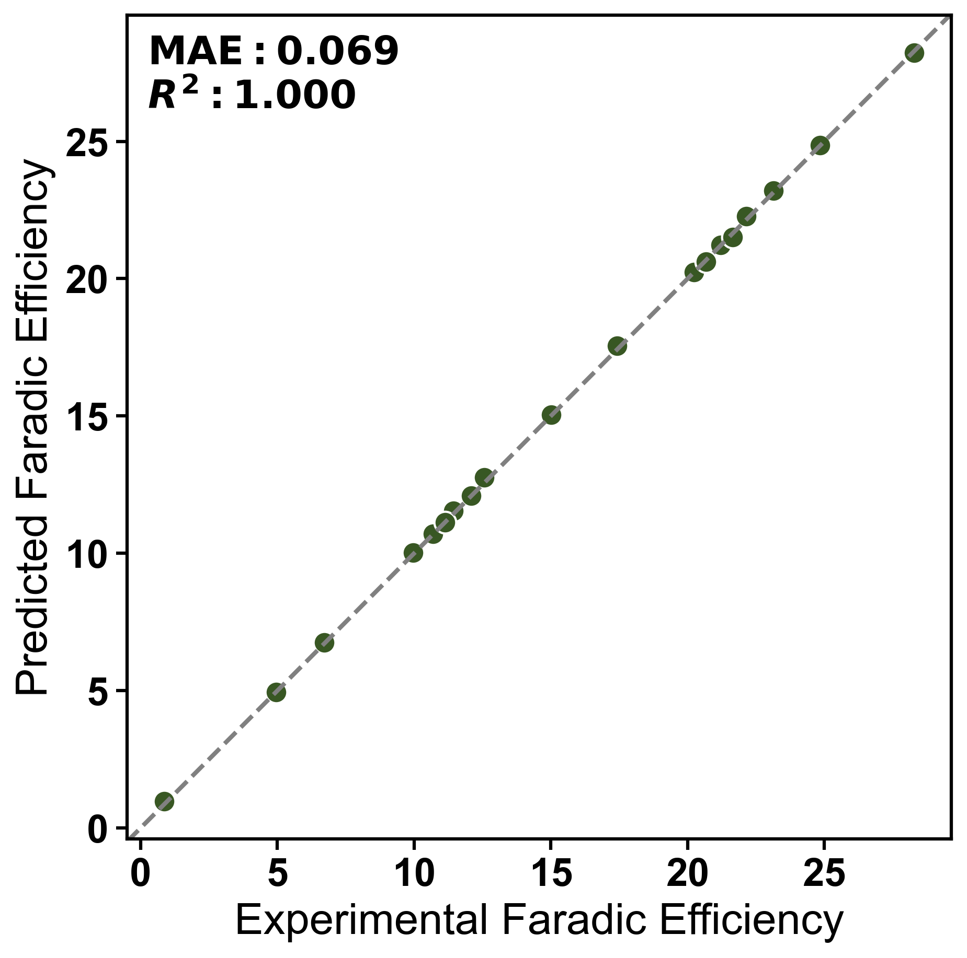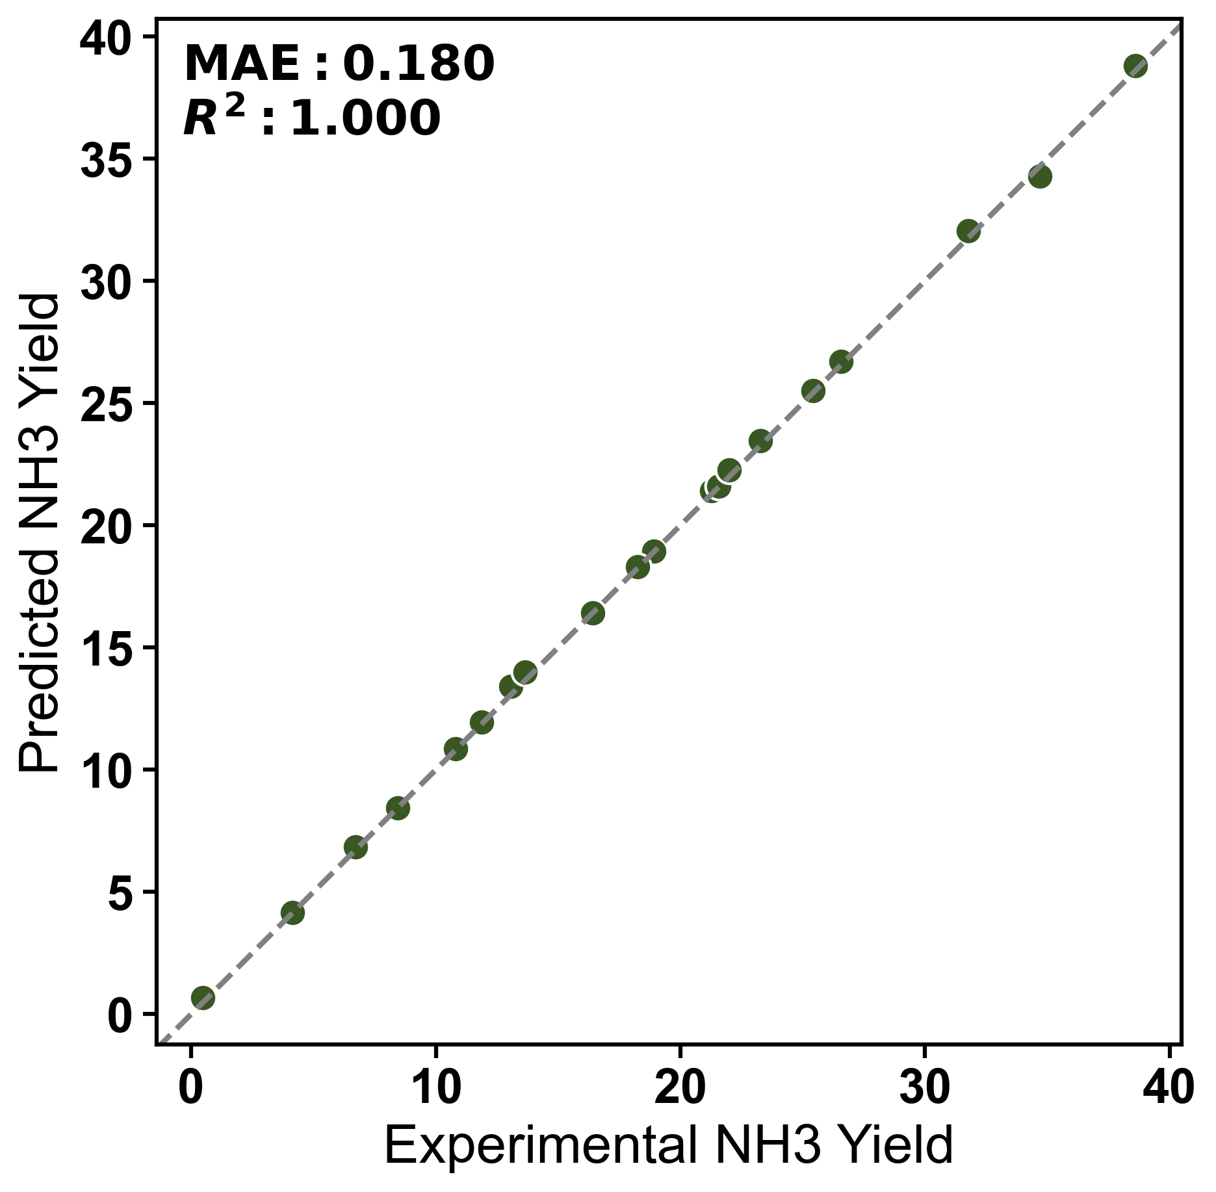
a)
b)
Figure S24. Comparison of experimental values and XGBoost model predictions for a) Faradaic efficiency and b) NH₃ yield.

Figure S25. I-t curve obtained by 4 wt. % Mo/C-N-21 in optimized GDE condition for 10 hours eNRR experiment at -0.2 V vs. RHE.

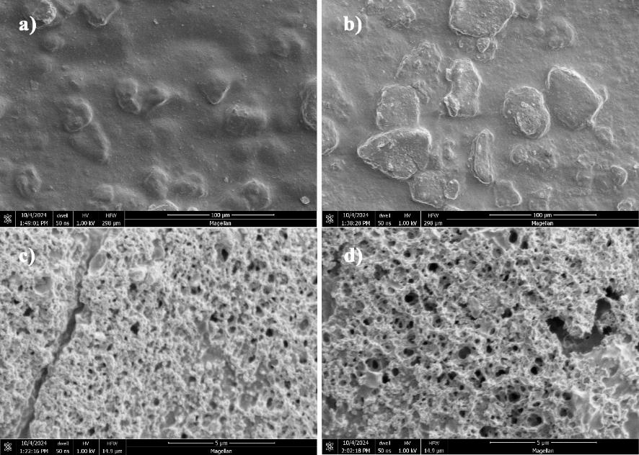
Figure S26. SEM images of 4 wt. % Mo/C-N-21 in optimized GDE condition before (a,c) and after (b,d) 10 hours eNRR at -0.2 V vs. RHE.

Figure S27. XPS analysis of 4 wt. % Mo/C-N-21 in optimized GDE condition after 10 hours eNRR at -0.2 V vs. RHE.

Table S3. Summary of prior studies on electrochemical NH₃ synthesis.
Catalysts | Electrolyte | Potential  (vs. RHE) | NH₃ Yield Rate (μg∙h⁻¹∙mg⁻¹) | FE [%] | References
Mo-PNC | 0.1 M KOH | -0.2 V | 34.7 | 21.6 | This work
VN NPs | 0.05 M H₂SO₄ | -0.1 V | 20.2 | 6 | J. Am. Chem. Soc. 2018, 140, 13387.
Cr₂O₃ | 0.1 M Na₂SO₄ | -0.9 V | 3.04 | 6.78 | ACS Catal. 2018, 8, 8540.
C@CoS@TiO₂ | 0.1 M Na₂SO₄ | -0.55 V | 49.51 | 28.6 | Angew. Chem., Int. Ed. 2019, 58, 18903.
GDY/Co₂N | 0.1 M HCl | -0.2 V | 219.72 | 58.6 | Angew. Chem., Int. Ed. 2020, 59, 13021.
Fe–Ni LDH | 0.1 M Na₂SO₄ | -0.5 V | 10.53 | 23 | Angew. Chem., Int. Ed. 2020, 59, 13623.
Cu/PI-300 | 0.1 M KOH | -0.3 V | 12.4 | 6.56 | Nat. Commun. 2019, 10, 4380.
Cu-TiO₂/CP | 0.5 M LiClO₄ | -0.55 V | 21.31 | 21.99 | Adv. Mater. 2020, 32, 2000299.
Nb₂O₅ nanofiber | 0.1 M HCl | -0.55 V | 43.6 | 9.26 | Nano Energy 2018, 52, 264.
2D W₂N₃ | 0.1 M KOH | -0.2 V | 11.66 | 11.67 | Adv. Mater. 2019, 31, 1902709.
PC/Sb/SbPO₄ | 0.1 M HCl | -0.25 V | 25 | 31 | Angew. Chem., Int. Ed. 2019, 58, 13329.
Sc/NC | 0.1 M HCl | -0.1 V | 20.4 | 11.2 | ACS Nano 2020, 14, 1093.
Y/NC | 0.1 M HCl | -0.1 V | 23.2 | 12.1 | ACS Nano 2020, 14, 1093.
Re₂MnS₆ | 0.1 M Na2SO4 | -0.3 V | 15 | 14 | Nano Lett. 2020, 20, 4960.
Fe-ReS₂ | 0.1 M Na₂SO₄ | -0.2 V | 80.4 | 12.3 | Adv. Funct. Mater. 2020, 30, 1907376.
THH Au NRs | 0.1 M KOH | -0.2 | 1.648 | 4.02 | Adv. Mater. 2017, 29, 1604799.
Vr-ReSe₂@CBC | 0.1 M Na₂SO₄ | -0.25 | 28.3 | 42.5 | Angew. Chem., Int. Ed. 2020, 59, 13320.
Ru SAs/N-C | 0.05 M H₂SO₄ | -0.2 | 120.9 | 29.6 | Adv. Mater. 2018, 30, 1803498.
Ru@ZrO₂/NC | 0.1 M HCl | -0.11 | 3600 | 21 | Chem 2019, 5, 204.
Ru SAs/g-C₃N₄ | 0.05 M NaOH | 0.05 | 23 | 8.3 | Adv. Funct. Mater. 2020, 30, 1905665.
Pd/C | 0.05 M H₂SO₄ | 0.1 | 4.5 | 8.2 | Nat. Commun. 2018, 9, 1795.
PdH_{0.43} | 0.1 M PBS | -0.15 | 20.4 | 43.6 | Angew. Chem., Int. Ed. 2020, 59, 3511.
PdPb nanosponges | 0.1 M HCl | 0.05 | 25.68 | 5.79 | Appl. Catal., B 2020, 265, 118481
Pd_{0.2}Cu_{0.8}/rGO | 0.1 M KOH | -0.2 | 2.8 | 0.6 | Adv. Energy Mater. 2018, 8, 1800124.
PdCu/NC | 0.05 M H₂SO₄ | -0.45 | 69.2 | 24.8 | Angew. Chem., Int. Ed. 2020, 133, 349.
NPG@ZIF-8 | 0.1 M Na₂SO₄ | -0.8 | 28.7 | 44 | Angew. Chem., Int. Ed. 2019, 58, 15362.
AuHNCs | 0.5 M LiClO₄ | -0.4 | 3.9 | 30.2 | Nano Energy 2018, 49, 316.
Au/TiO₂ | 0.1 M HCl | -0.2 | 21.4 | 8.11 | Adv. Mater. 2017, 29, 1606550.
α-Au/CeOx-RGO | 0.1 M HCl | -0.2 | 8.3 | 10.1 | Adv. Mater. 2017, 29, 1700001.
Au₆/Ni | 0.05 M H₂SO₄ | -0.14 | 7.4 | 67.8 | J. Am. Chem. Soc. 2019, 141, 14976.
Au/CoOx | 0.05 M H₂SO₄ | -0.5 | 15.1 | 19 | Angew. Chem., Int. Ed. 2019, 58, 18604.
ISAS-Fe/NC | 0.1 M PBS | -0.4 | 62.9 | 18.6 | Nano Energy 2019, 61, 420.
Fe SA-N-C | 0.1 M KOH | 0 | 7.48 | 56.55 | Nat. Commun. 2019, 10, 341.
Fe-N/C | 0.1 M KOH | -0.2 | 34.83 | 9.28 | ACS Catal. 2019, 9, 336.
FePc/C | 0.1 M Na₂SO₄ | -0.3 | 137.95 | 10.5 | ACS Catal. 2019, 9, 7311.
Mo₃Fe₃C | 0.1 M Li₂SO₄ | -0.05 | 1.23 | 27 | Nano Energy 2020, 68, 10437.
SA-Mo/NPC | 0.1 M KOH | -0.3 | 34 | 14.6 | Angew. Chem., Int. Ed. 2019, 58, 2321.
Mo0/GDY | 0.1 M HCl | -0.1V | 2 | 15.6 | J. Am. Chem. Soc. 2019, 141, 10677.
MoS₂/CC | 0.1 M Na₂SO₄ | -0.5 | 4.96 | 1.17 | Adv. Mater. 2018, 30, 1800191.
DR MoS₂/CPE | 0.1 M Na₂SO₄ | -0.4 | 29.28 | 8.34 | Adv. Energy Mater. 2018, 8, 1801357.
Co-doped MoS_{2-x} | 0.01 M H₂SO₄ | -0.3 | 10.2 | 10 | J. Am. Chem. Soc. 2019, 141, 19269.
Ti₃C₂T_{x} (TO, OH) | 0.1 M HCl | -0.3 | 36.9 | 9.1 | ACS Energy Lett. 2019, 4, 1053.
MXene/TiFeOx-700 | 0.05 M H₂SO₄ | -0.2 | 21.9 | 25.44 | ACS Nano 2020, 14, 9089.
TiO₂/Ti₃C₂T_{x} | 0.1 M HCl | -0.55 | 32.17 | 16.07 | Adv. Energy Mater. 2019, 9, 1803406.
Zr-TiO2 | 0.1 M KOH | -0.45 | 8.9 | 17.3 | Nat. Commun. 2019, 10, 2877.
Bi NS | 0.1 M Na₂SO₄ | -0.8 | 13.23 | 10.46 | ACS Catal. 2019, 9, 2902.
BiNCs with K+ | 0.5 M K₂SO₄ | -0.6 | 884 | 66 | Nat. Catal. 2019, 2, 448.
PEBCD with Li+ | 0.5 M Li₂SO₄ | -0.7 | 2.01 | 2.85 | J. Am. Chem. Soc. 2017, 139, 9771.
PCN-NVx | 0.1 M Na₂SO₄ | -0.2 | 8.09 | 11.59 | Angew. Chem., Int. Ed. 2018, 57, 10246.
NPC | 0.05 M H₂SO₄ | -0.9 | 23.8 | 1.42 | ACS Catal. 2018, 8, 1186.
C-ZIF | 0.1 M KOH | -0.3 | 57.8 | 10.2 | Nano Energy 2018, 48, 217.
CNS | 0.25 M LiClO₄ | -1.19 | 97.18 | 11.56 | Sci. Adv. 2018, 4, e1700336.
BG | 0.05 M H₂SO₄ | -0.5 | 9.8 | 10.8 | Joule 2018, 2, 1610.
B-BCN | 0.05 M Na₂SO₄ | -0.6 | 8.39 | 9.87 | Appl. Catal., B 2021, 283, 119622.
BNS | 0.1 M Na₂SO₄ | -0.8 | 13.22 | 4.04 | ACS Catal. 2019, 9, 4609.
FL-BP NSs | 0.01 M HCl | -0.7 | 31.37 | 5.07 | Angew. Chem., Int. Ed. 2019, 58, 2612.

Figure S28. a) Plots of Faradaic efficiencies and NH₃ yield rates summarized in table S1 and recent reports of flow cells.

Figure S29. (a) Current density and Faradaic efficiencies of flow cell with 4 wt. % Mo/N-C-21 GDE under DC voltage. (b) V-I curve and calculated power density, in which scatter line represents the actually power density for ammonia production.

